Can we pass an object of a subclass to a method expecting an object of the super class?B14. Are static members inherited to sub classes?

Ans:

Yes, in object-oriented programming, you can pass an object of a subclass to a method that expects an object of the superclass. This behavior is an essential feature of polymorphism, particularly subtype polymorphism. When you pass a subclass object to a method that expects a superclass object, the method can operate on the subclass object as if it were a superclass object, as long as the methods and properties used by the method are available in the superclass.

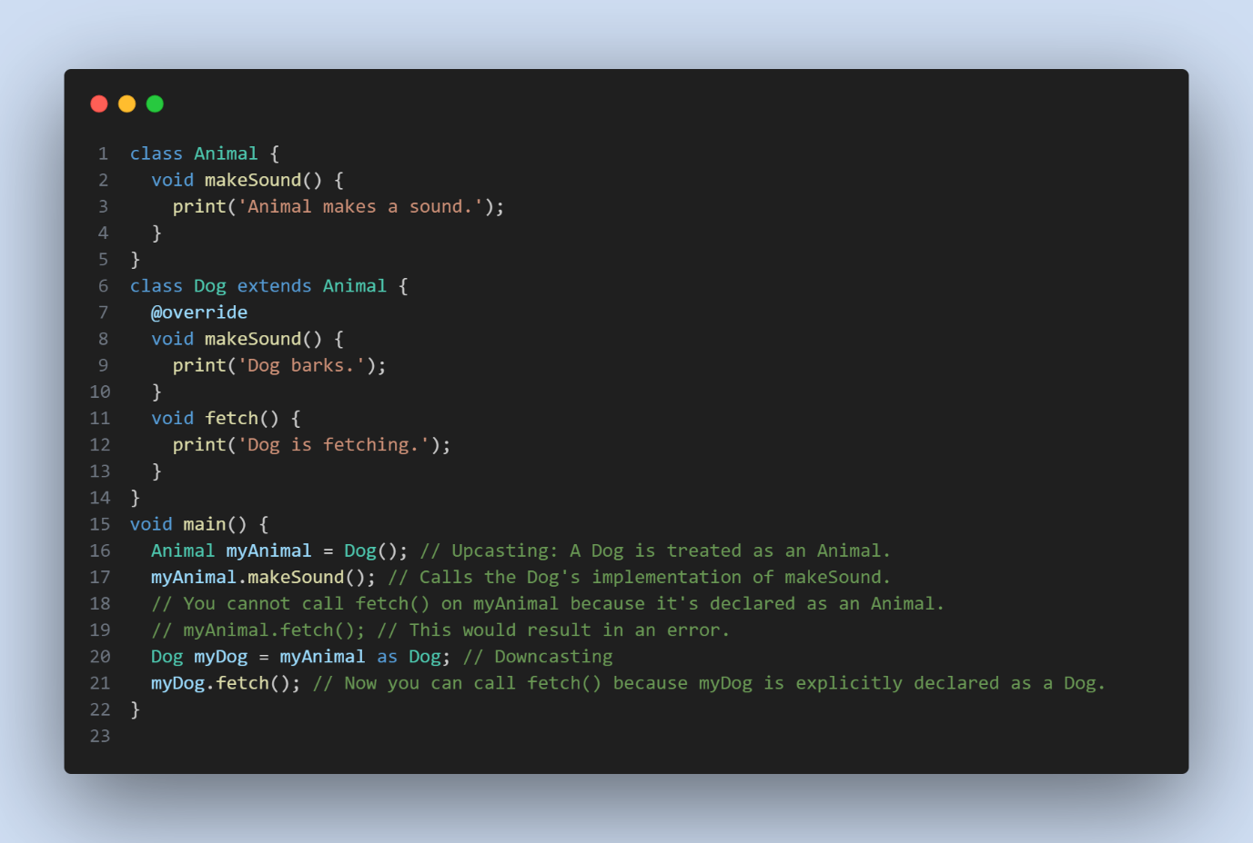

B14 :

In object-oriented programming languages like Dart, static members (static fields and static methods) are not inherited by subclasses. Static members belong to the class itself rather than instances of the class, and they are not part of the class's inheritance hierarchy.